DSA0179-OBJECT ORIENTED PROGRAMMING WITH C++

DAY-2 PROGRAMS

K.Sree Durga Geethika

192111472,CSE.

1. Write a program to print the area and perimeter of a triangle having sides of 3,4 and 5 units by creating a class named ‘Triangle’ With a function to print the area and perimeter.

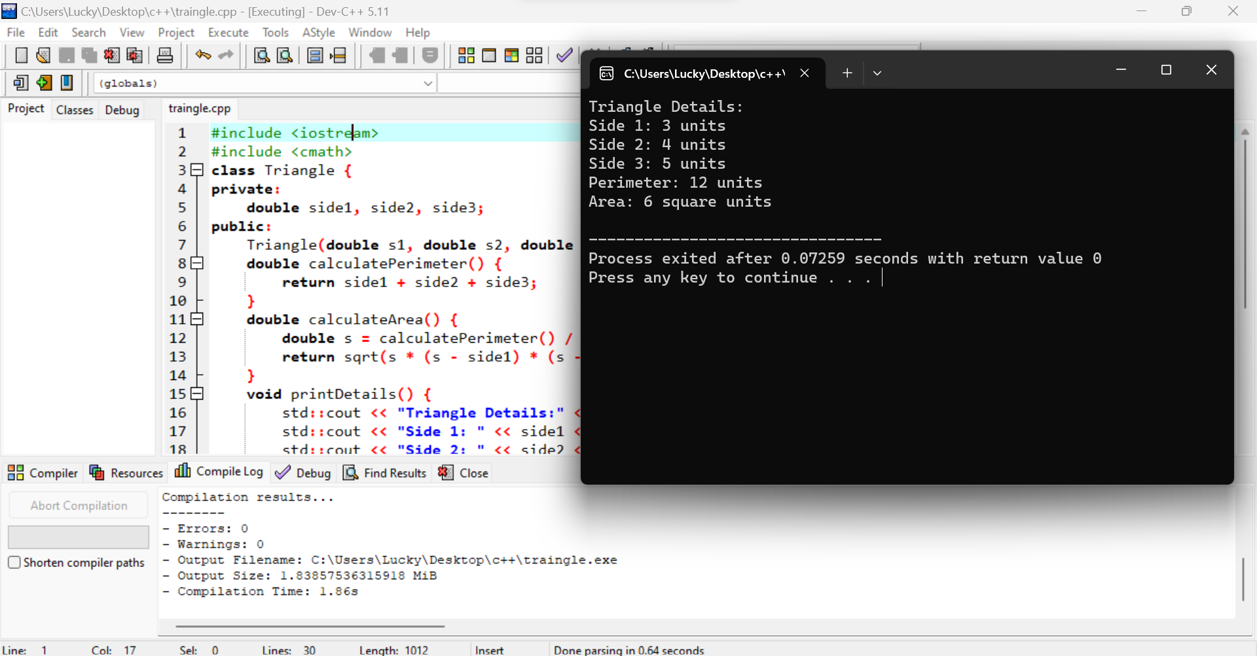

1. Write a program to find the sum of the series  
   1!/1+2!/2+3!/3+4!/4+5!/5

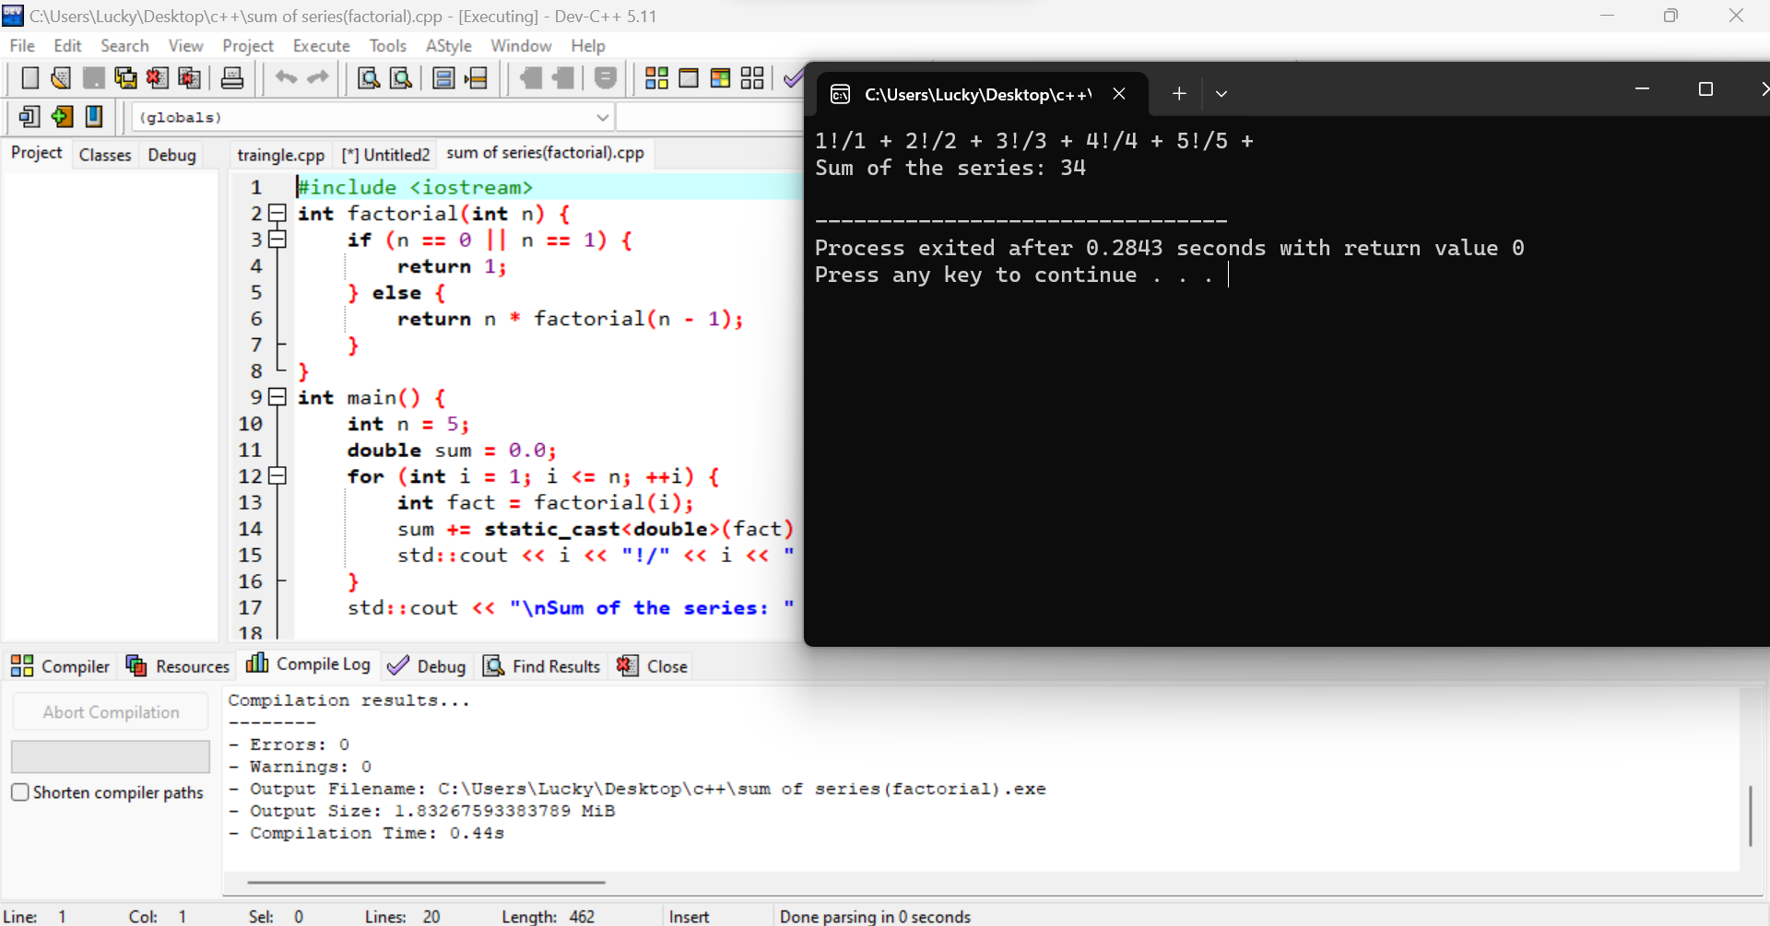

1. Write a c ++ program to find smallest element missing in a sorted natural numbers  
   array?

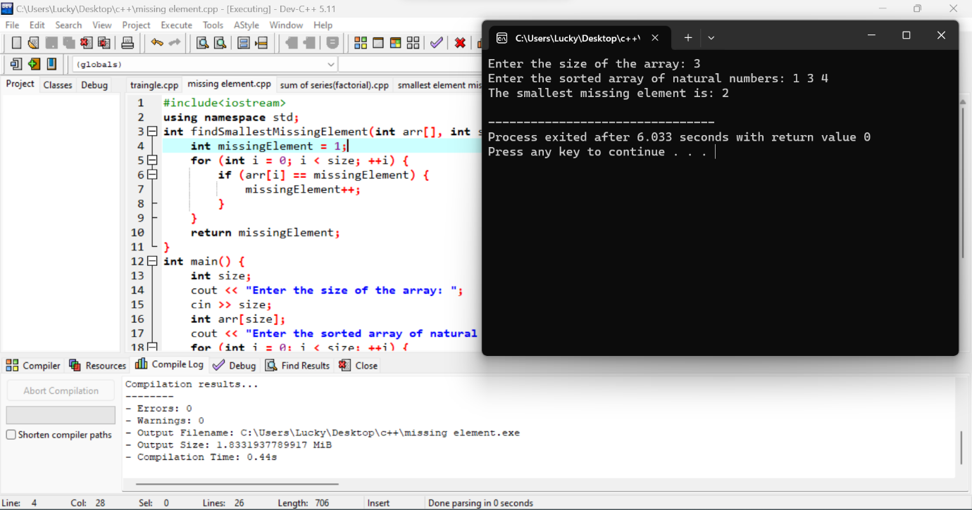

1. Write a program to order the array of elements  
   in non-Decreasing order.

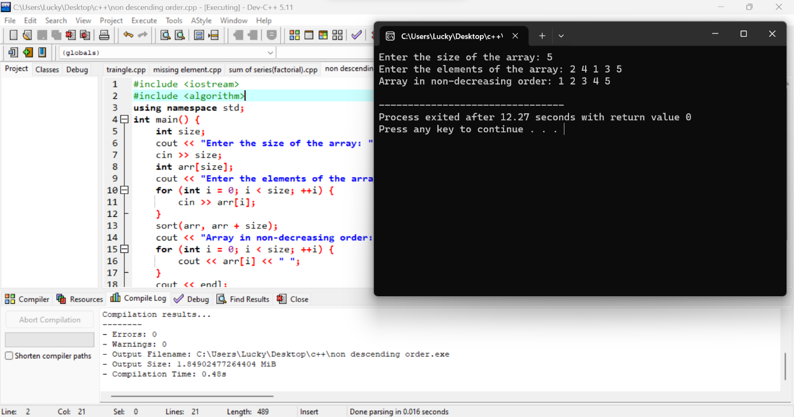

1. Write a program in C++ to store n elements in an array, sort  
   and print the elements using pointer.

